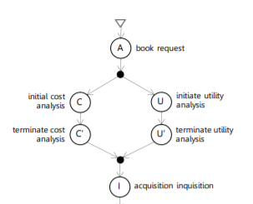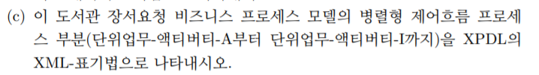

1. A

<Activitys>

<Activity Id=“Activity001” Name=”book request”>

<Activity>

<Activitys>

1. Transition001

<Transition>

<Transitions>

<Transition Id=”Transition001 From=”Activity001” To=”Activity002” Name=”Start_To_AND_Split”>

</Transition>

</Transitions>

1. AND

<Activitys>

<Activity Id=”Activity002” Name=”AND_SPLIT”>

<Route GatewayType=”AND” />

<TransitionRestrictions>

<TransitionRestriction>

<Split Type=”AND”>

<TransitionRefs>

<TransitionRef Id=”Transition002 />

<TransitionRef Id=”Transition006 />

</TransitionRefs>

</Split>

</TransitiononRestriction>

</TranstionRestrictions>

</Activity>

</Activitys>

1. Transition002

<Transition>

<Transitions>

<Transition Id=”Transition002 From=”Activity002” To=”Activity003” Name=”Start_To_Initial cost analysis”>

</Transition>

</Transitions>

1. C

<Activitys>

<Activity Id=“Activity003” Name=”initial cost analysis”>

<Activity>

<Activitys>

1. Transition003

<Transitions>

<Transition Id=”Transition003 From=”Activity003” To=”Activity004” Name=”Start_To_terminate cost analysis”>

</Transition>

</Transitions>

1. C’

<Activitys>

<Activity Id=“Activity004” Name=”terminate cost analysis”>

<Activity>

<Activitys>

1. Transition004

<Transitions>

<Transition Id=”Transition004 From=”Activity004” To=”Activity003” Name=”Start_To_AND_JOIN”>

</Transition>

</Transitions>

1. AND

<Activitys>

<Activity Id=”Activity005” Name=”AND_JOIN”>

<Route GatewayType=”AND” />

<TransitionRestrictions>

<TransitionRestriction>

<Split Type=”AND”>

<TransitionRefs>

<TransitionRef Id=”Transition005 />

</TransitionRefs>

</Split>

</TransitiononRestriction>

</TranstionRestrictions>

</Activity>

</Activitys>

1. Transition006

<Transitions>

<Transition Id=”Transition006 From=”Activity002” To=”Activity007” Name=”Start_To_initiate utility analysis”>

</Transition>

</Transitions>

1. U

<Activitys>

<Activity Id=“Activity006” Name=”initial utility analysis”>

<Activity>

<Activitys>

1. Transition007

<Transitions>

<Transition Id=”Transition007 From=”Activity006” To=”Activity007” Name=”Start_To_terminate utility analysis”>

</Transition>

</Transitions>

1. U’

<Activitys>

<Activity Id=“Activity007” Name=”terminate utility analysis”>

<Activity>

<Activitys>

1. Transition008

<Transitions>

<Transition Id=”Transition008 From=”Activity007” To=”Activity005” Name=”Start_to_AND_JOIN”>

</Transition>

</Transitions>

1. Transition009

<Transitions>

<Transition Id=”Transition009 From=”Activity005” To=”Activity008” Name=”Start_to_acquisition inquisition”>

</Transition>

</Transitions>

1. I

<Activitys>

<Activity Id=“Activity008” Name=”acquisition inquisition”>

<Activity>

<Activitys>

(d)

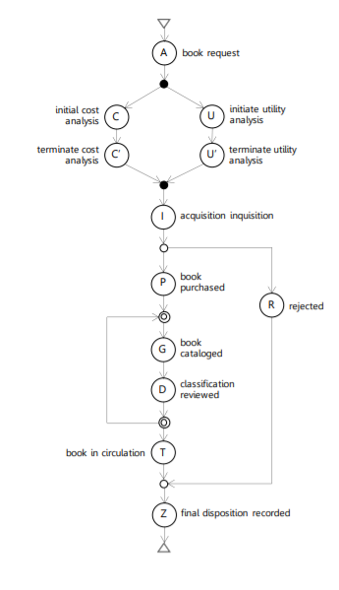

|  |  |  |  |  |
| --- | --- | --- | --- | --- |
| STEP | SET OF ACTIVITIES | SELECTED ACT | USED BB | NEW ACT |
| 1 | A | A | SEQUENTIAL | I |
| 2 | AI | A | SEQUENTIAL | C |
| 3 | ACI | C | AND | U |
| 4 | ACUI | C | SEQUENTIAL | C’ |
| 5 | ACC’UI | U | SEQUENTIAL | U’ |
| 6 | ACC’UU’I | I | SEQUENTIAL | P |
| 7 | ACC’UU’IP | P | OR-SPLIT | R |
| 8 | ACC’UU’IPR | PR | OR-JOIN | Z |
| 9 | ACC’UU’IPRZ | P | SEQUENTIAL | T |
| 10 | ACC’UU’IPTRZ | P | SEQUENTIAL | G |
| 11 | ACC’UU’IPGTRZ | G | DO-WHILE | D |
| 12 | ACC’UU’IPGDTRZ | T | SEQUENTIAL |  |
| 13 | ACC’UU’IPGDTRZ |  |  |  |

